Article ID: [1114]
Article Name: How do I clean the filter of my Dryer?
Topic Location: Laundry , Dryer , usage , Filter/ fluff
Meta-data: Filter , Clean , Lint
Related Articles:
Related Questions:
PNC
DIY
Safety
Link
Email
Book Engineer
Multimedia
Brand
Article Content:
The filter of your appliance can be found in the door or in the porthole. Remove the filter from the holder. The lint may be easily removed by rubbing along the filter. After cleaning the filter, place the filter in the holder. Your appliance is ready to use.

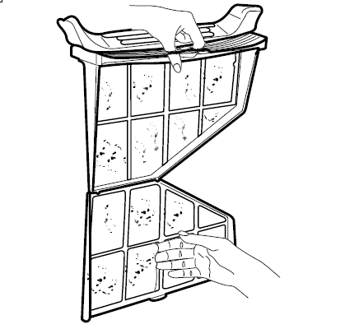
http://services.electrolux-medialibrary.com/picture/553x553/ehppdb-pictures/G/B/PN/PSGBFL140G002231.jpg

